Intestine Slide Opener

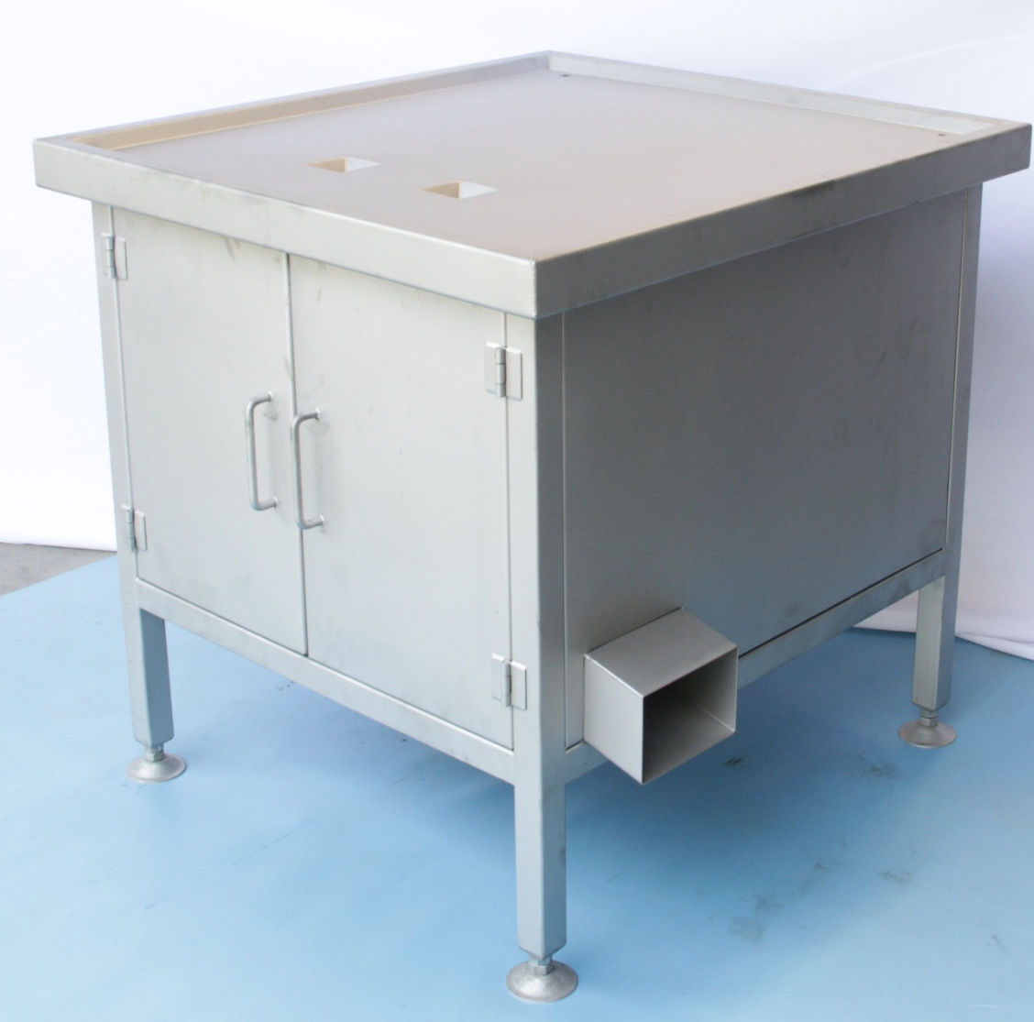

- Please read this manual carefully before using
- Operate and maintain the equipment according to the requirements of this manual
- When the equipment fails to operate, please deal with it according to this manual
- This manual should be properly kept.

Security Warning
- 1. Please read this manual before installing, debugging and maintaining the equipment.
- 2. Motor and electrical control cabinet wiring must be connected to the ground.
- 3. Do not put your hand into the machine during the operation of the equipment.
- 4. Please shutdown the equipment when it fails to operate normally.
- 5. The machine must be disconnected from the power supply during the equipment maintenance.
- 6. Please be sure to pay attention to safety measures during the installation, debugging and maintenance of the equipment.

Intestine Slide Opener
I. Function
The machine is used for opening of the chicken intestine.
The working principle is to open the chicken intestine by a high speed rotating blade when the intestine was tightly-fitted driven by a concave shape roller passing through rotating blade. The split intestine will drop into the collection trough after slide opening.

II. Main Technical Parameters
1. Processing object: Intestine. To straighten the intestine and to remove the intestine fat
2. Capacity: 1000pcs / hour/ person (100g/ piece)
3. There are two working position every machine.
4. Model No. PCJ-S
5. Size of the machine: 840*810*818mm (the operation table size can be customized)
6. Power of the motor: 075kW, Protection Grade: IP65
7. Voltage: 380 V 3ph; Frequency: 50HZ

Safety Notice for Usage and Maintenance

- Regular checking of the bearings to replace the broken or damaged one with brand-new bearings when detecting the broken parts and the damages during the regular checking. Replace all the bearings after 6 months working.
- Regular changing of the gear box oil to extend the service life of the gearbox.
3. Do not drain and splash water onto the motor when cleaning the machine.

